**EMPLOYEE ONBOARDING BOT**

**A PROJECT REPORT**

***Submitted by***

**REUBEN ABRAHAM GEORGE (220701223)**

***in partial fulfillment for the course***

**OAI1903 - INTRODUCTION TO ROBOTIC PROCESS AUTOMATION**

***for the degree of***

**BACHELOR OF ENGINEERING**

***in***

**COMPUTER SCIENCE AND ENGINEERING**

**RAJALAKSHMI ENGINEERING COLLEGE RAJALAKSHMI NAGAR THANDALAM CHENNAI – 602 105**

**NOVEMBER 2024**

**RAJALAKSHMI ENGINEERING COLLEGE CHENNAI - 602105**

**BONAFIDE CERTIFICATE**

Certified that this project report **“Employee Onboarding Bot”** is the bonafide work of **“REUBEN ABRAHAM GEORGE (220701223)”** who carried out the project work for the subject OAI1903 - Introduction to Robotic Process Automation under my supervision.

|  |  |
| --- | --- |
|  | **SIGNATURE**  **DR. N. DUARAIMURUGAN**  **SUPERVISOR,**  Assistant Professor (SG) ,  Department of  Computer Science and Engineering,  Rajalakshmi Engineering College,  Rajalakshmi Nagar,  Thandalam,  Chennai – 602105. |

Submitted to Project and Viva Voce Examination for the subject OAI1903 -

Introduction to Robotic Process Automation held on .

**Internal Examiner External Examiner**

**ABSTRACT**

The "Employee Onboarding Bot" is a Robotic Process Automation (RPA) solution developed using UiPath to streamline the onboarding process for new employees. This bot automates form filling, document verification, and email communication, ensuring efficient and error-free onboarding. The automation reduces the manual workload of HR teams, enhances the accuracy of onboarding procedures, and improves the overall experience for new hires.

The bot compiles all onboarding data into a dynamically generated Excel file to ensure transparency and streamlined reporting. This report includes detailed logs of processed employee records, flagged issues, and the overall status of the onboarding pipeline. By automating these tasks, the bot enhances operational efficiency, reduces human errors, and improves the onboarding experience for new hires.

Key functionalities include:

1. Collecting and verifying employee details.
2. Automating document uploads and notifications.
3. Generating personalized welcome emails.
4. Compiling an onboarding summary in Excel.

This project showcases the potential of RPA to simplify repetitive HR tasks, making it a valuable addition to modern business operations.

**ACKNOWLEDGEMENT**

Initially we thank the Almighty for being with us through every walk of our life and showering his blessings through the endeavour to put forth this report. Our sincere thanks to our Chairman **Mr. S. Meganathan, B.E, F.I.E.,** our Vice

Chairman **Mr. Abhay Shankar Meganathan, B.E., M.S.,** and our respected Chairperson **Dr. (Mrs.) Thangam Meganathan, Ph.D.,** for providing us with the requisite infrastructure and sincere endeavouring in educating us in their premier institution.

Our sincere thanks to **Dr. S.N. Murugesan, M.E., Ph.D.,** our beloved Principal for his kind support and facilities provided to complete our work in time.

We express our sincere thanks to **Dr. P. Revathy, M.E., Ph.D.,** Professor and Head of the Department of Computer Science and Design for her guidance and encouragement throughout the project work. We convey our sincere and deepest gratitude to our internal guides, **Mrs. Roxanna Samuel, M.E.,** Assistant Professor (SG), **Ms. Farjana, M.E.,** Assistant Professor (SG), **Ms. Vinothini,**

**M.E.,** Assistant Professor (SG), Department of Computer Science and Engineering, Rajalakshmi Engineering College for their valuable guidance throughout the course of the project. We are very glad to thank our Project Coordinators, **Dr. N. Durai Murugan, M.E., Ph.D.,** Associate Professor, and

**Mr. B. Bhuvaneswaran, M.E.,** Assistant Professor (SG), Department of Computer Science and Engineering for their useful tips during our review to build our project.

**Reuben Abraham George (220701223)**

**TABLE OF CONTENTS**

**CHAPTER NO. TITLE PAGE NO.**

LIST OF FIGURES vi

LIST OF ABBREVIATIONS vi

INTRODUCTION 1

1.1 BACKGROUND 1

1.2 PROBLEM STATEMENT 1

1.4 BENEFITS OF AUTOMATION IN ONBOARDING 2

1.7 EXISTING SYSTEM 3

1.8 PROPOSED SYSTEM 4

LITERATURE REVIEW 6

SYSTEM DESIGN 10

3.1 SYSTEM FLOW DIAGRAM 10

3.2 ARCHITECTURE DIAGRAM 11

3.3 SEQUENCE DIAGRAM 11

PROJECT DESCRIPTION 13

4.1. MODULES: 13

4.1.1. INPUT HANDLING AND INITIALIZATION: 13

4.1.2 DOCUMENT VERIFICATION: 13

4.1.3 EMAIL AUTOMATION: 14

4.1.4 COMPLETION AND REPORTING: 14

OUTPUT SCREENSHOTS 15

CONCLUSION 19

APPENDIX 20

## LIST OF FIGURES

|  |  |  |
| --- | --- | --- |
| **Figure No.** | **Figure Name** | **Page No.** |
| 3.1 | System Flow Diagram | 9 |
| 3.2 | Architecture Diagram | 10 |
| 3.3 | Sequence Diagram | 11 |
| 5.1 | Input Dialog | 14 |
| 5.2 | Excel Report Generation | 14 |
| 5.3 | Document Verification Status | 15 |
| 5.4 | Automated Email Notification Screenshot | 16 |
| 5.5 | Final Onboarding Summary Report | 17 |

## LIST OF ABBREVIATIONS

|  |  |
| --- | --- |
| **ABBREVIATION** | **ACRONYM** |
| RPA | Robotic Process Automation |
| OCR | Optical Character Recognition |

**CHAPTER 1**

# INTRODUCTION

## 1.1 BACKGROUND

The onboarding process is a cornerstone of human resources management, ensuring that new employees transition smoothly into an organization. This process typically involves multiple stages, such as data collection, document verification, orientation scheduling, and follow-up communications. While essential, traditional onboarding methods are often manual, repetitive, and prone to delays and errors, particularly in large-scale recruitment scenarios.

With the rise of automation technologies like Robotic Process Automation (RPA), there is a significant opportunity to address these inefficiencies. UiPath, a leading RPA platform, offers tools to automate such repetitive tasks, enabling businesses to streamline workflows, minimize errors, and enhance overall productivity. The "Employee Onboarding Bot," built using UiPath, is designed to address these challenges by automating key steps of the onboarding lifecycle. Its scalability and adaptability make it a valuable asset for organizations of all sizes, ensuring seamless and efficient integration of new employees into the workplace.

## 1.2 PROBLEM STATEMENT

Traditional employee onboarding processes face several challenges:

1. Time-Consuming Tasks: Manual data entry, document verification, and email communications can take hours for each employee, slowing down the onboarding pipeline.
2. Human Errors: Repetitive tasks increase the likelihood of mistakes, such as incorrect data entry or missed communications.
3. Lack of Standardization: Variability in procedures can lead to inconsistencies, affecting both the organization's compliance and the new hire's experience.
4. Scalability Issues: Handling a large volume of new hires simultaneously is difficult without significant HR resources, leading to potential delays.

## 1.4 BENEFITS OF AUTOMATION IN ONBOARDING

The "Employee Onboarding Bot" leverages the capabilities of RPA to transform HR workflows:

* **Efficiency**: Reduces the time required to complete onboarding tasks, allowing HR teams to onboard more employees in less time.
* **Accuracy**: Minimizes errors in data entry and document handling through automated validation and logging.
* **Consistency**: Standardizes onboarding procedures across the organization, ensuring compliance with internal and external requirements.
* **Enhanced Employee Experience**: Provides new hires with timely and accurate information, fostering a positive impression of the organization.

**1.5 RELEVANCE OF UIPATH IN HR AUTOMATION**

UiPath is an industry leader in RPA, known for its user-friendly interface, robust capabilities, and scalability. Its drag-and-drop workflow designer and prebuilt automation components make it ideal for automating HR processes. The "Employee Onboarding Bot" utilizes UiPath’s strengths, including:

* **Data Extraction and Validation**: Automated handling of forms and documents using UiPath’s data processing activities.
* **Integration**: Seamless interaction with email servers, Excel files, and HR management systems.
* **Error Handling**: Built-in mechanisms to log and report issues for manual intervention.

By harnessing UiPath’s features, the "Employee Onboarding Bot" addresses the critical challenges of traditional onboarding methods, setting a new benchmark for efficiency and accuracy in HR operations.

**1.6 OBJECTIVE**

The primary goal of the "Employee Onboarding Bot" is to revolutionize the traditional onboarding process by automating key activities. This project aims to:

* Automate data collection and validation, ensuring completeness and correctness of employee information.
* Streamline document verification to reduce manual intervention.
* Enhance communication through automated, personalized email generation.
* Provide real-time reporting and tracking of the onboarding process for HR teams.

By achieving these objectives, the bot ensures a seamless and efficient onboarding experience, both for HR professionals and new employees.

## 1.7 EXISTING SYSTEM

The existing employee onboarding process in most organizations is predominantly manual, involving multiple repetitive tasks that are both time-consuming and resource-intensive. HR personnel are required to collect information from new hires, verify the authenticity of submitted documents, manage email communications, and compile reports. These activities often lead to the following challenges. Manual processes demand significant time and effort, especially during bulk onboarding, such as after-mass recruitment drives. Manually sending emails and responding to queries can delay critical updates, affecting the onboarding timeline.

## 1.8 PROPOSED SYSTEM

The "Employee Onboarding Bot" presents a transformative solution to the limitations of the existing system by leveraging UiPath's Robotic Process Automation (RPA) platform. This proposed system automates key stages of the onboarding workflow, offering the following features:

1. **Data Collection and Validation**
   * Automates the input of new hire information through structured forms.
   * Ensures completeness and accuracy of data through predefined validation rules.
2. **Document Verification**
   * Automatically verifies submitted documents against set formats and requirements.
   * Flags discrepancies or missing documents for manual review.
3. **Email Automation**
   * Sends personalized emails to new hires with welcome messages, joining instructions, and required information.
   * Notifies HR teams of incomplete submissions or issues for prompt action.
4. **Real-Time Reporting**
   * Dynamically generates and updates an Excel-based report summarizing the onboarding status of all employees.
   * Provides a comprehensive overview, including completed tasks and pending actions.
5. **Scalability**
   * Handles a large volume of onboarding tasks simultaneously, making it ideal for organizations with high recruitment needs.

The proposed system addresses the inefficiencies of manual processes by ensuring swift, consistent, and accurate execution of onboarding tasks. It not only reduces the workload for HR teams but also enhances the onboarding experience for new hires, positioning organizations to better handle their workforce integration needs.

**CHAPTER 2**

# LITERATURE REVIEW

**2.1 Survey on Robotic Process Automation (RPA) in Education:**

Robotic Process Automation (RPA) has been increasingly recognized as a transformative tool in human resource management. HR departments across industries are adopting RPA to automate routine tasks such as payroll processing, recruitment, and onboarding. Studies highlight several benefits of implementing RPA in HR, including increased efficiency, improved accuracy, and enhanced employee satisfaction. However, challenges such as the initial cost of implementation and integration with existing systems have also been noted. The literature review of research papers related to RPA in Education is listed below:

1. The research discusses the rise of Artificial Intelligence (AI), robotics, and other digital technologies are creating a demand for new professions with evolved digital skills. A report published by the *International Journal of Automation and Computing* explored the use of RPA in HR processes, emphasizing its potential to reduce operational costs by 30–40%. The study concluded that onboarding automation is one of the most impactful use cases of RPA, as it eliminates repetitive, high-volume tasks.

1. Research from *SpringerLink* highlighted the scalability of RPA in HR, particularly in handling large-scale recruitment and onboarding, allowing organizations to process thousands of new hires simultaneously without delays or errors.
2. According to PwC’s 2020 HR technology survey, 45% of HR leaders plan to invest in hyper-automation or Robotic Process Automation (RPA) technology ahead of the 12-24 months. With RPA, HR professionals will find that they no longer have to spend hours filling positions, updating job descriptions, and conducting interviews with candidates.

**2.2 Automation in Document Verification:**

Document verification is a critical step in onboarding that traditionally demands significant manual effort. Automating this process with OCR and AI-based validation tools has demonstrated substantial efficiency gains.

1. **Study 1: Automated Verification with UiPath**  
   A whitepaper by *UiPath Labs* explored the integration of OCR with RPA workflows for document verification. It detailed a case study of a financial institution where bots processed over 5,000 employee records during onboarding. The OCR technology accurately extracted and validated fields such as employee IDs, addresses, and dates of birth with an accuracy rate exceeding 95%. This eliminated manual cross-checking and reduced processing times from days to minutes.
2. **Study 2: Leveraging AI for Document Validation**  
   A study published in *IEEE Access* examined AI-enhanced RPA for document validation in government onboarding processes. By combining machine learning models with RPA, the system detected anomalies in submitted documents, such as forged IDs or incomplete information. The hybrid system achieved a 98% detection accuracy rate while processing 1,000 documents per hour.
3. **Study 3: Streamlining Compliance through Automation**  
   Research by *Gartner* on compliance management noted that automated document verification tools ensured 100% compliance with regulatory requirements. Bots flagged non-compliant submissions and prompted follow-ups, reducing penalties associated with onboarding errors.

**2.3 Automated Communication in HR:**

Effective communication during onboarding is essential for ensuring new hires feel informed and valued. Automation enhances communication consistency and responsiveness while reducing manual workload.

1. **Study 1: Personalized Communication for Enhanced Engagement**  
   A study from the Journal of Human Resources found that onboarding bots capable of sending personalized welcome emails and follow-ups significantly improved employee engagement. In one case, an IT firm noted a 30% reduction in onboarding-related queries due to timely and clear communication from an automated bot.
2. **Study 2: Chatbots in Onboarding Communication**  
   Research by Accenture detailed the use of chatbots to address common onboarding questions. Chatbots trained on company policies handled up to 85% of queries without HR intervention, such as inquiries about work schedules, benefits, and documentation requirements. This reduced the response time to under a minute, enhancing the overall onboarding experience.
3. **Study 3: Notification Systems for HR Teams**  
   A report by McKinsey & Company highlighted the benefits of automated notifications for HR teams. Bots provided real-time updates on onboarding progress, alerting HR personnel about pending tasks or missing documents. This proactive approach improved task completion rates by 25%.

**2.4 Summary of RPA Applications in Onboarding:**

The surveyed literature highlights the critical role of RPA in addressing inefficiencies, errors, and scalability issues in onboarding. By automating tasks such as document verification, data handling, and communication, organizations can:

1. **Increase Efficiency**: Automating repetitive tasks accelerates the onboarding timeline.
2. **Enhance Accuracy**: Bots reduce human error in processes like data validation and compliance checks.
3. **Improve Employee Experience**: Automated communications ensure clarity and timely updates for new hires.
4. **Enable Scalability**: Organizations can handle large volumes of new employees without adding HR resources.

.

**CHAPTER 3**

# SYSTEM DESIGN

## 3.1 SYSTEM FLOW DIAGRAM

A flowchart is a type of diagram that represents an algorithm, workflow or process. The flowchart shows the steps as boxes of various kinds, and their order by connecting the boxes with arrows. This diagrammatic representation illustrates a solution model to a given problem. The system flow diagram for this project is in Fig. 3.1.

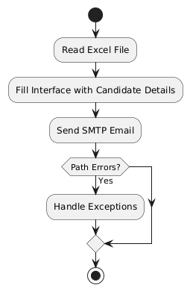

Fig 3.1 System Flow Diagram

## 3.2 ARCHITECTURE DIAGRAM

An architecture diagram is a graphical representation of a set of concepts, that are part of an architecture, including their principles, elements and components. The architecture diagram for this project is in Fig. 3.2.

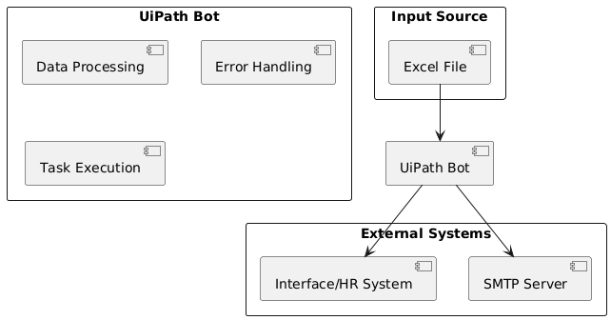

Fig 3.2 Architecture Diagram

## 3.3 SEQUENCE DIAGRAM

A sequence diagram is a type of interaction diagram because it describes and shows in what order a group of objects works together. The sequence diagram for this project is in Fig. 3.3.

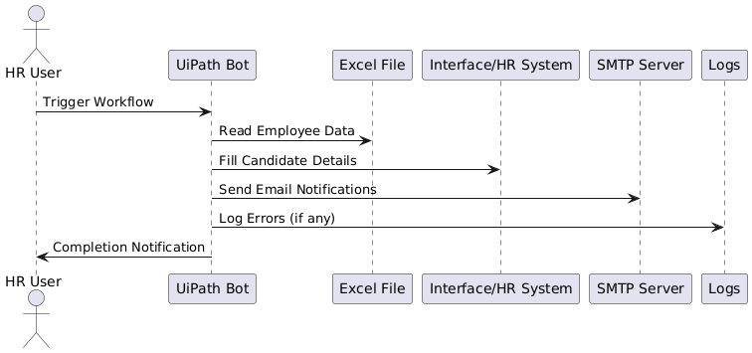

Fig 3.3 Sequence Diagram

**CHAPTER 4**

# PROJECT DESCRIPTION

The "Employee Onboarding Bot" is a comprehensive RPA solution developed using UiPath to address inefficiencies in traditional onboarding processes. This chapter provides a detailed breakdown of the project's modules, describing their functionality, workflow, and technical implementation. Developed using UiPath, the system is modular and scalable, enabling seamless integration with existing HR tools and databases.

## 4.1. MODULES:

### 4.1.1. INPUT HANDLING AND INITIALIZATION:

* **Functionality:**
  + Prompts HR personnel to input employee details or upload a structured input file (e.g., Excel or CSV).
  + Reads and parses the input data using UiPath's Excel and File Handling activities.
* **Key Features:**
  + Validates mandatory fields (e.g., Name, Employee ID, Contact Information).
  + Checks for formatting errors, such as invalid email addresses or phone numbers.

### 4.1.2 DOCUMENT VERIFICATION:

* **Functionality:**
  + Extracts text from documents using UiPath's OCR engines (e.g., Google OCR or ABBYY).
  + Compares extracted data against predefined templates or formats for validation.
* **Key Features:**
  + Flags discrepancies such as missing fields, incorrect formats, or mismatched data.
  + Logs issues in a report for manual follow-up.

### 4.1.3 EMAIL AUTOMATION:

* **Functionality:**
  + Generates personalized emails for new hires with joining instructions, contact information, and other onboarding details.
  + Sends reminders to HR personnel about pending tasks or incomplete submissions**.**
* **Key Features:**
  + Templates for various email types (e.g., welcome emails, reminders, follow-ups).
  + Tracks sent emails and confirms delivery using UiPath's SMTP/Outlook activities.

### 4.1.4 COMPLETION AND REPORTING:

* **Completion Message:** 
  + Provides real-time updates through a user-friendly dashboard.
  + Generates a final onboarding summary report.

**CHAPTER 5**

# OUTPUT SCREENSHOTS

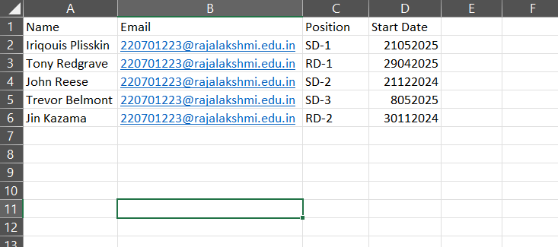

Fig 5.1 – Excel Sheet

The bot get the employee details from the mentioned excel sheet “EmployeeDetails” as shown in Fig 5.1.

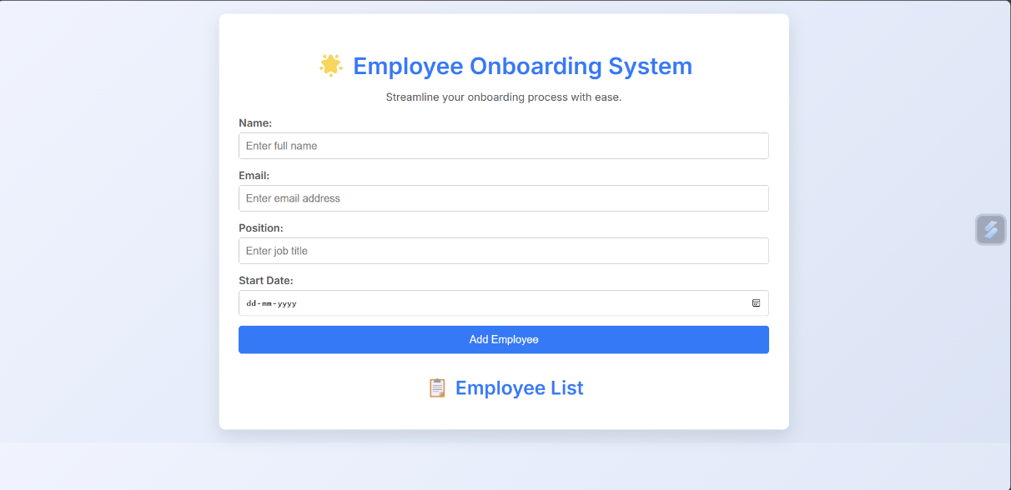

Fig 5.2 – Open HR System

The bot opens the HR System Interface and “Types Into” the form details as shown in Fig 5.2.

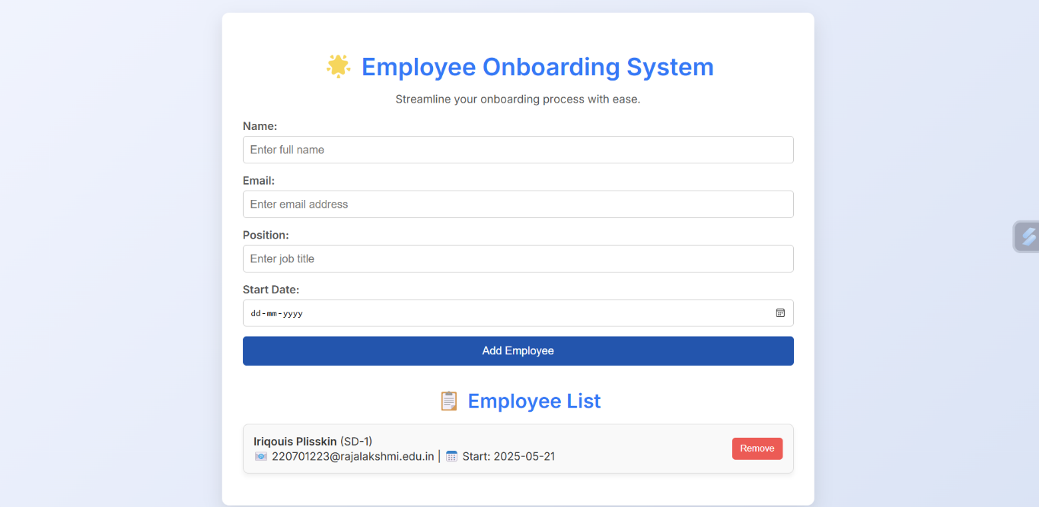

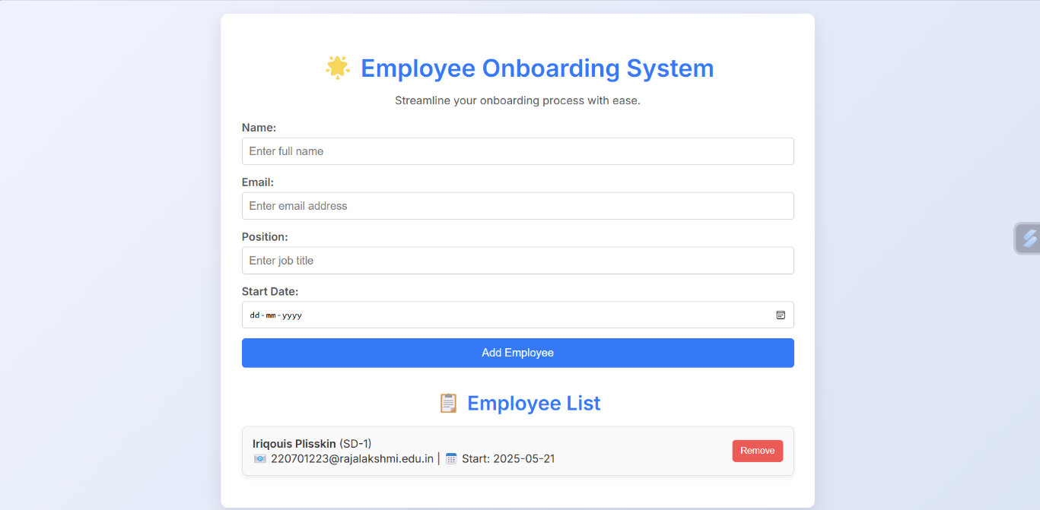

Fig 5.3 – Data Filling

The content from each Excel document is Typed Into the fields of the HR System content as it is shown in Fig 5.3. The Excel content detection results are read and is stored to a variable for later use. The result shows if the Automated and perfectly checked, also the probability of the content being entirely written by the “Employee Onboarding Bot” using automation.

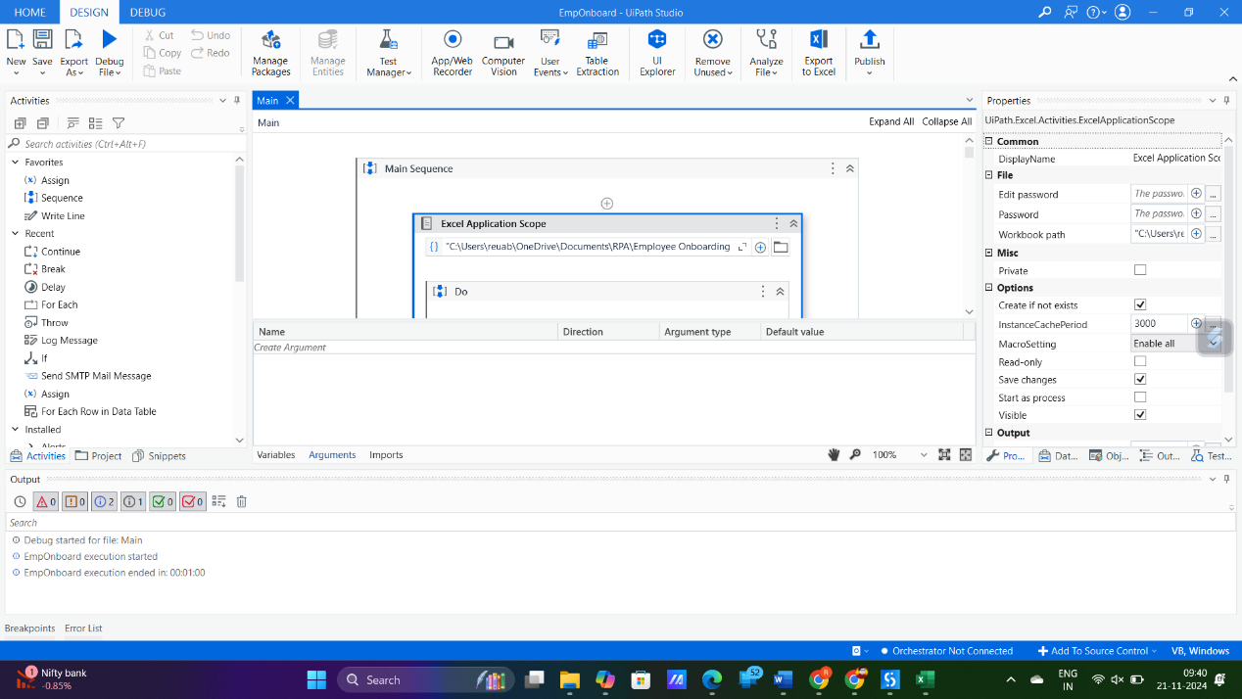

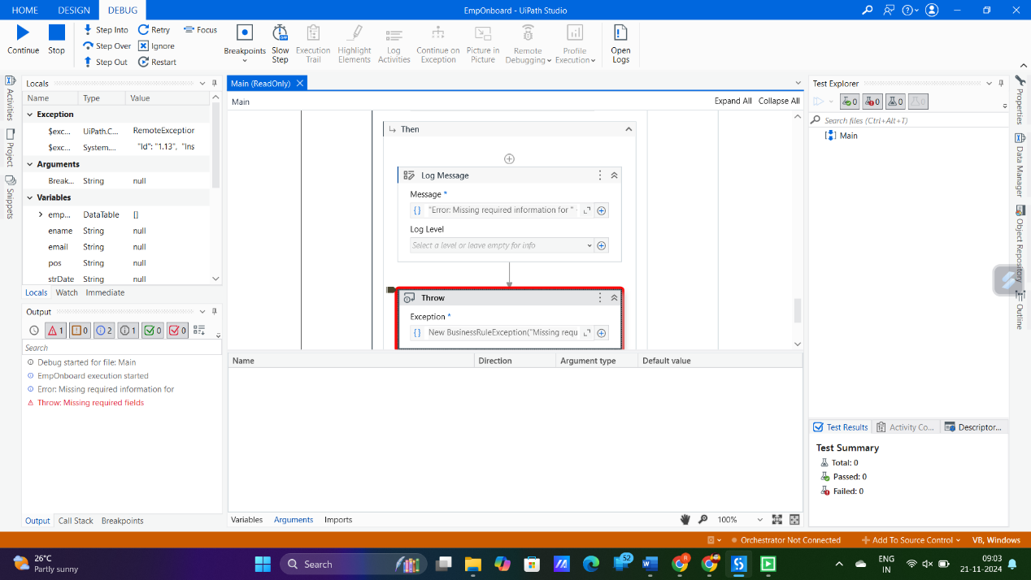

Fig 5.4 – Exception Handling

The content from each Excel document is run through an external source for detecting Plagiarism as shown in Fig 5.4. The results get collected by the Get Text Activity and is stored in another variable for later use. The result shows how unique the assignment content is (in percentage).

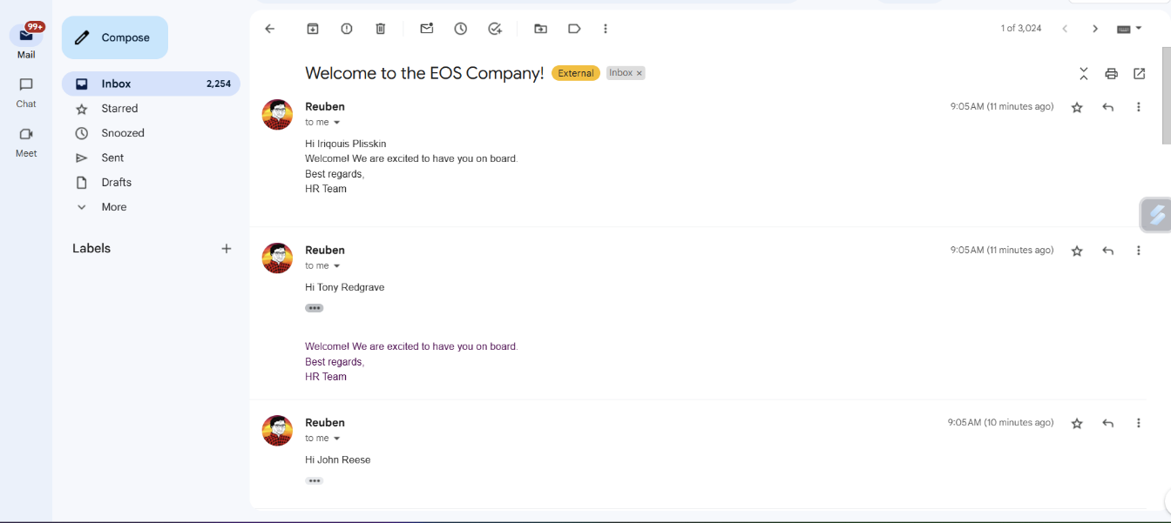

Fig 5.5 – Automated Email Notification Screenshot

The results are then sent to the employee mail addresses and saved as it is shown in Fig 5.5.

**CHAPTER 6**

# CONCLUSION

The "Employee Onboarding Bot" demonstrates the immense potential of Robotic Process Automation (RPA) in transforming HR workflows. By automating repetitive tasks like data collection, document verification, and email communication, the bot enhances efficiency and accuracy while reducing the manual burden on HR teams. This automation not only streamlines the onboarding process but also ensures a consistent and professional experience for new hires, fostering smoother integration into the organization.

The bot’s dynamic reporting capabilities provide real-time insights, allowing HR teams to track progress and maintain transparency throughout the onboarding process. Despite minor challenges such as processing unstructured data or integrating with legacy systems, the bot’s robust design and scalability make it a reliable solution for organizations of all sizes.

Future enhancements, including AI integration, multilingual support, and advanced analytics, could further elevate the bot’s functionality, addressing complex scenarios and delivering predictive insights. These developments would make the bot an even more versatile and intelligent tool for HR automation.

In summary, the "Employee Onboarding Bot" effectively addresses traditional onboarding inefficiencies, enabling organizations to modernize their processes and focus on strategic HR initiatives. As organizations embrace digital transformation, such automation tools will play a pivotal role in creating efficient, scalable, and employee-friendly systems.

## APPENDIX

**PROCESS WORK FLOW**

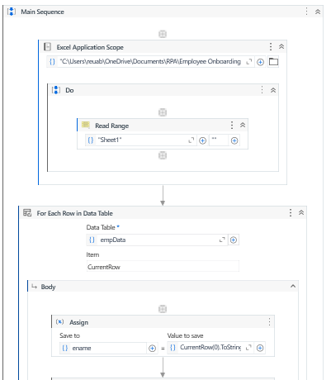

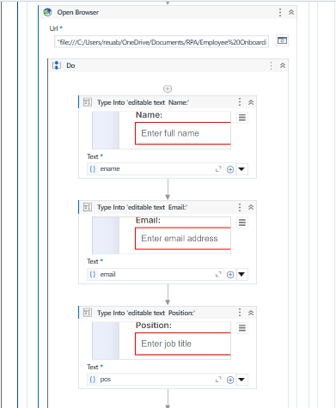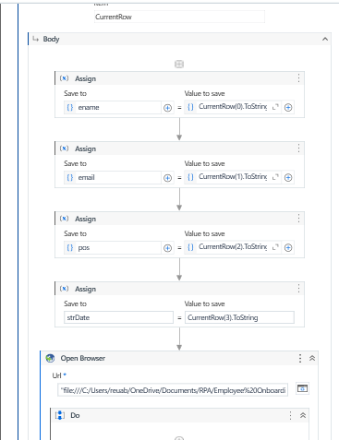

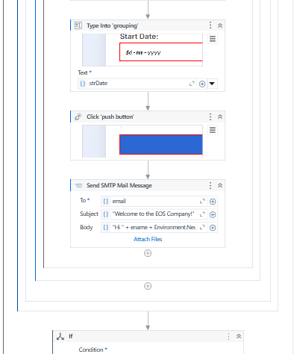

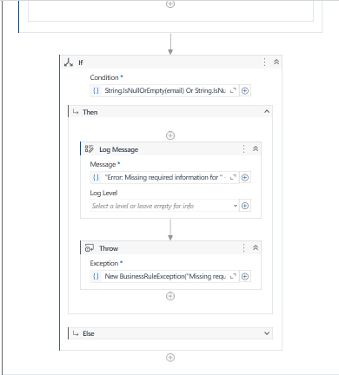

**REFERENCES**

1. **UiPath Documentation**

* Source: https://docs.uipath.com/

1. **Excel Activities in UiPath**

* Source: https://docs.uipath.com/activities/docs/excel

1. **SMTP Email Automation with UiPath**

* Source: https://docs.uipath.com/activities/docs/send-smtp-mail-message

1. **Exception Handling in UiPath**

* Source: https://docs.uipath.com/studio/docs/exception-handling

1. **OCR and Data Extraction with UiPath**

* Source: https://docs.uipath.com/activities/docs/ocr-text-extraction

1. **Research on RPA in Human Resources**

* Article: *Automating Human Resource Functions: A Robotic Process Automation Perspective*
* Source: International Journal of Advanced Research in Computer Science

1. **Case Study: Automating Onboarding with UiPath**

* Source: UiPath Blog - https://www.uipath.com/blog

1. **Introduction to Robotic Process Automation in HR**

* Book: *Robotic Process Automation: A Guide for HR Professionals*
* Authors: James Manos and Sarah Riggs

1. **Impact of Automation on Employee Satisfaction**

* Study: *The Role of RPA in Enhancing Employee Experience During Onboarding*
* Published in: *Journal of Business Process Management*